Chapter 1: Preparing Your Environment
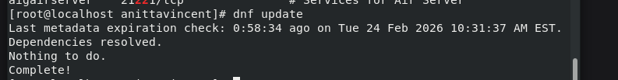
Used dnf update to update all the distribution’s software
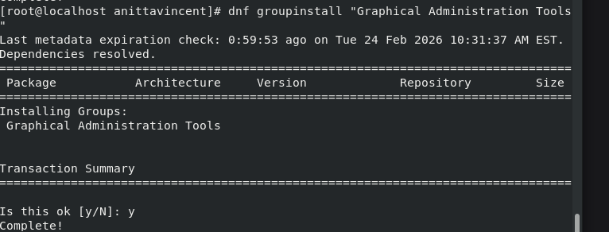
Used dnf groupinstall command to install a graphical environment
Set the Graphical Environment as the default boot environment using above command.

------------------------------------------------------------------------------------------------------------------

Chapter 2: Sifting Through Services
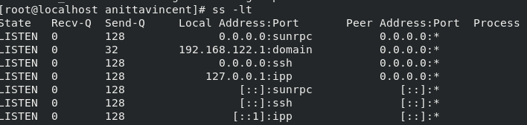
Shows all TCP ports that are in LISTENING state. (ss = socket statistics
-l = listening, -t = TCP )

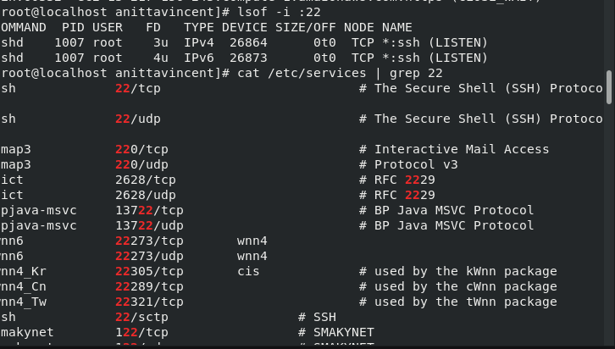
lsof -i :22 command shows which process is using TCP/UDP port 22 on the system. Port 22 is normally used by SSH (Secure Shell). lsof → list open files, -i → filter by network connections, :22 → match port 22 (any protocol: TCP or UDP)
Using cat /etc/services | grep 22 command, filter the lines containing 22 from content of the file /etc/services. Basically, shows all service names that use port 22.

----------------------------------------------------------------------------------------------------------------
Chapter 3: Managing Files, Directories, and Text
3a. Perform Basic File Management
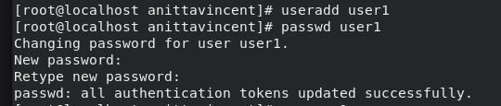
Added a user called user1 and set the password for it.
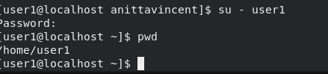
Logged in as user1 and verified if the present working directory is the user1’s home directory.
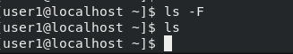
ls command doesn’t list any files or folders as the home folder is empty.

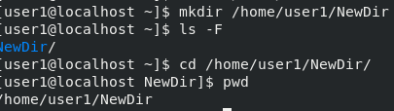
Made a new directory called NewDir and made sure it is listed using ls -F.
Navigated to the NewDir using cd command followed by absolute directory reference and verified the present working directory using pwd command.
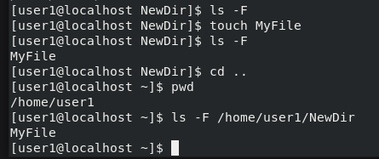
Created a file called MyFile using touch command and listed it using ls -F command.
Navigated to the previous level (/home/user1) using cd .. and verified the present working directory using pwd, verified if MyFile is listed using ls -F followed by absolute directory reference of the file.
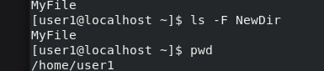
Used ls with relative path as well and verified MyFile is listed.
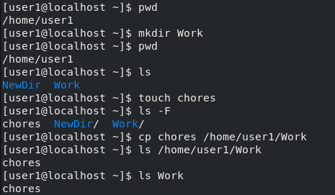
Made a directory named Work, verified if it is created using ls, made a file Chores and copied the Chores file inside Work folder and verified it using ls
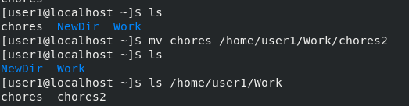
Moved the chores file to Work folder and renamed as chores2 file and verified that chores is removed from present directory using ls and chores2 is present in /home/user1/work using ls /home/user1/work.
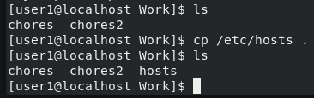
Copied the /etc/hosts file to the present working directory
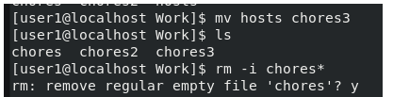
Renamed the hosts file to chores3 and kept it in the present working directory. Removed the chores files, by the command rm -i chores*
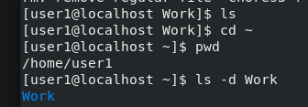
Made sure if the chores files are deleted by typing ls. Change present directory to user1’s home directory using cd ~ and verified it using pwd. Checked to see if the Work subdirectory is located here, by typing ls -d Work
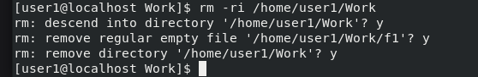
Deleted the Work directory and files currently located in it. (Note: created a file named f1 inside the Work directory for the sake of performing this step)
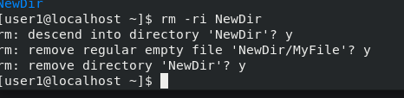
Deleted the NewDir directory and files currently located in it, by typing rm -ri NewDir (relative reference)

3b. Create and Change Hard and Symbolic Links
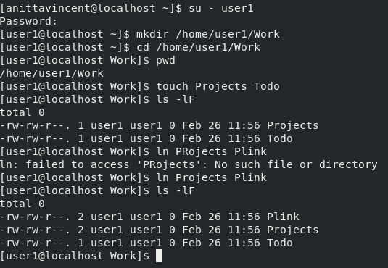
Logged in as user1 and made a directory called Work in user1’s home directory. Navigate to Work directory and created the files Projects and Todo. Created a hard link between the pre-existing file, Projects, and the file Plink. ls -lF P* gives the second column of information for the files Projects and PLink. The number there is the “Link Count.” The link count for these two files, Projects and PLink are at two (2). This is because each of them is linked to another file. In this case, they are linked to each other.
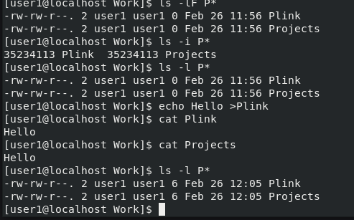
In the command, ls -i P* the –i option on the ls command displays numbers called “inode numbers.” Noticed that the inode numbers for both the Projects and the PLink files are the exact same number. This is because these two files are hard linked and thus share the same inode number.
In the command ls -l P*, noticed that the size (5th column) of both the files Projects and PLink are 0. echo Hello >Plink command puts the word Hello into the PLink file, making the file no longer empty. cat PLink command lets see the output Hello.
cat Projects helps verify that the file Projects has the same information in it as PLink. This is due to them being hard linked together.
ls -l P*: size of both the files Projects and PLink have a size greater than 0 and are the exact same size. Once again, this Is due to them being hard linked together.
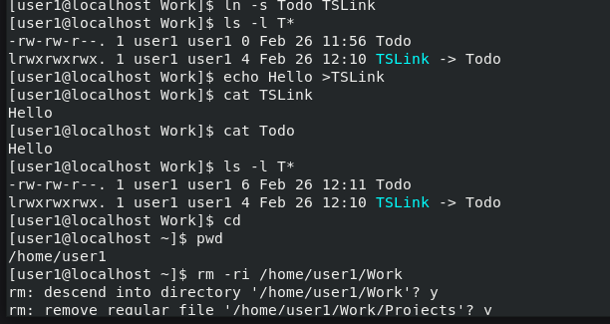
ln -s Todo TSLink creates a symbolic link (soft link) to the file Todo. ls -l T: The –l option (lowercase L) on the ls command gives you a long listing, which includes some helpful information for symbolic links. By echo Hello >TSLink put the word Hello into the empty file TSLink.
Type cat TSLink and press Enter. Could see the word Hello.
cat Todo: Could see the word Hello here too. These two files are not data twins like a hard linked file.
ls -l T*: The –l option (lowercase L) on the ls command gives you a long listing. The files
sizes are different. Instead, the symbol link file, TSLink , is merely a pointer to the file Todo where the data is stored.
Go back to the user1 home directory by typing cd.
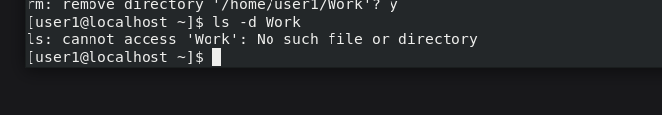
Remove the work directory using rmdir command and verified it using ls -d Work command
3c Finding Files
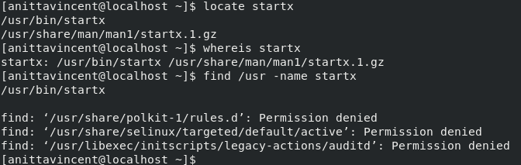
Logged in as normal user and displayed several filenames that include the string startx.
Using whereis startx command the system responds with the names of a few files that
contain the string startx.
find /usr -name startx: returns several “permission denied” error messages. It also returns a single line listing the /usr/bin/startx program file.
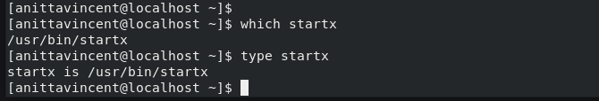
which startx.: returns the complete filename of the first instance of startx the system finds on its path.
type startx: identify startx as an external command stored at /usr/bin/startx

